Project 2: SQL Data Insights

## Top Baby Names in California

### **Query:**

SELECT name, gender, SUM(number) as total

FROM `bigquery-public-data.usa_names.usa_1910_2013`

WHERE state = 'CA'

GROUP BY name, gender

ORDER BY total DESC

LIMIT 10;

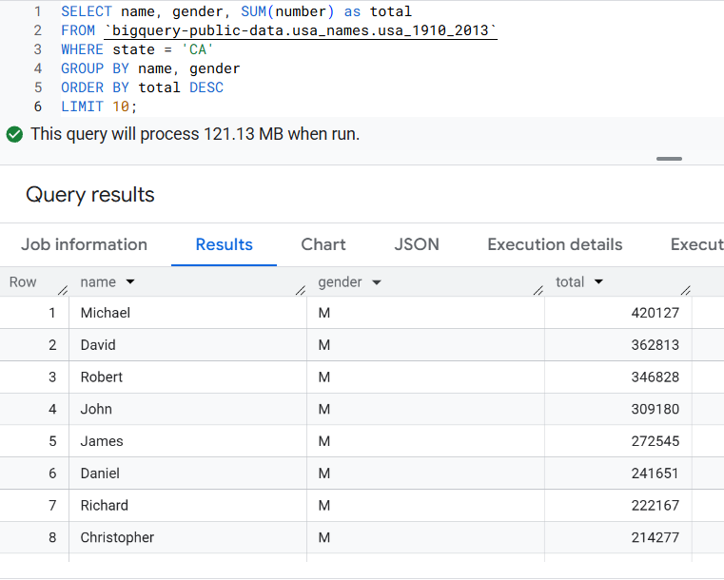

## COVID-19 Deaths by Country:

### **Query:**

SELECT country_name, SUM(cumulative_deceased) AS total_deaths

FROM `bigquery-public-data.covid19_open_data.covid19_open_data`

WHERE date = '2021-06-01'

GROUP BY country_name

ORDER BY total_deaths DESC

LIMIT 10;

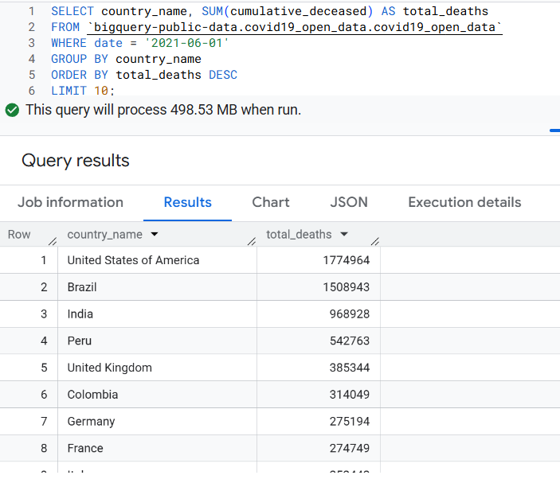

## NYC 311 Requests by Complaint Type:

### **Query:**

SELECT complaint_type, COUNT(*) AS total_complaints

FROM `bigquery-public-data.new_york.311_service_requests`

GROUP BY complaint_type

ORDER BY total_complaints DESC

LIMIT 10;

